Appendix 2.2 - Additional information: Emissions from road transport

Derivation of activity data

Cross-check with Energy Balance
The Energy Balance is also used to model transport-quantity structures in TREMOD. For example, the German Economic Institute (DIW) carries out a fuel-consumption calculation in order to derive total mileage travelled (DIW, 2002). Some of the results of the calculation, for automobile transports, are entered into TREMOD. The DIW uses a fuel-consumption calculation in order to determine total domestic mileage; TREMOD uses some other sources and assumptions to estimate total domestic mileage – especially for goods transports (cf. the detailed description in (Knörr, W., Höpfner, U., & Lambrecht, U. (2002)) (bibcite 1)). This estimate also takes the basic figures of the Energy Balance into account.
On the other hand, due to the many dependencies and uncertainties in the model, and to the basic data that must be taken into account, no feasible means is available for comparing mileage and energy consumption, for each year and each vehicle layer, in such a manner that the results yield the Energy Balance sum and the mileage and average energy consumption figures in the time series are plausible. For this reason, the TREMOD results for the fuel consumption are corrected, at the end of the process, in such a manner that the total for each reference year corresponds to the relevant figure in the Energy Balance.
Since TREMOD calculates fuel consumption in tonnes, the results first have to be converted into terajoule [TJ]. For this purpose the net calorific values of the Working Group on Energy Balances (AGEB) are used.
Table 1: Net calorific values for gasoline and diesel oil
 | Gasoline | Diesel Oil
1990-1992 | 43.543 MJ/kg | 42.704 MJ/kg
as of 1993 | 43.543 MJ/kg | 42.960 MJ/kg
Source: Working Group on Energy Balances (Arbeitsgemeinschaft Energiebilanzen)
The correction factors are derived in TREMOD separately for the various vehicle categories, as follows:
- Firstly, a correction factor for gasoline is derived from the calculated petrol consumption for all vehicle categories and from petrol sales pursuant to the Energy Balance.
- The correction factor for gasoline is then also used to bring fuel consumption of vehicles with diesel engines, among automobiles and other vehicles ≤ 3.5 t (light duty vehicles (LDV), and of motor homes and motorcycles (MC)), in line with the Energy Balance.
- The difference between the corrected diesel-fuel consumption of automobiles and of other vehicles ≤ 3.5 t and the Energy Balance is then allocated to heavy duty vehicles and busses.
- The correction factor for heavy duty vehicles and busses is then calculated from their energy consumption, as calculated in accordance with the domestic principle, and the pertinent difference, as calculated for this group, from the Energy Balance.
Table 2: Correction factors for adjustment of TREMOD estimates to the National Energy Balance
 | Gasoline fuels | Diesel fuels
 | PC, LDV, M2W | PC, LDV | HDV, Bus
1990 | 1.046 | 1.046 | 1.035
1995 | 1.012 | 1.012 | 0.991
2000 | 0.967 | 0.967 | 1.021
2005 | 0.917 | 0.917 | 0.838
2006 | 0.895 | 0.895 | 0.877
2007 | 0.882 | 0.882 | 0.833
2008 | 0.881 | 0.881 | 0.828
2009 | 0.870 | 0.870 | 0.867
2010 | 0.858 | 0.858 | 0.910
2011 | 0.867 | 0.867 | 0.891
2012 | 0.846 | 0.846 | 0.950
2013 | 0.867 | 0.867 | 0.960
2014 | 0.883 | 0.883 | 0.910
2015 | 0.881 | 0.881 | 0.926
2016 | 0.893 | 0.893 | 0.926
2017 | 0.908 | 0.908 | 0.926
2018 | 0.878 | 0.878 | 0.899
2019 | 0.880 | 0.880 | 0.910
Source: TREMOD (Knörr, W. et al. (2020a))

Allocation of biofuels, petroleum and LPG to the structural elements
The Energy Balance lists data for biofuels, petroleum and LPG for the transport sector. For purposes of importing into the CSE, the results for these fuels are derived as follows:
- Biodiesel is allocated to all structural elements with diesel engines, in keeping with their percentage shares of consumption of conventional diesel fuel.
- Bioethanol is allocated to all structural elements with gasoline engines, in keeping with their percentage shares of consumption of conventional gasoline.
- Petroleum is allocated to busses on roads outside of municipalities – and, thus, to the structural elements SV - BUS - KOAO and SV - BUS - MTAO – in keeping with their percentage shares of consumption of conventional diesel fuel.
- LPG is allocated to conventional automobiles, with petrol engines, on municipal roads (CSE nomenclature: SV - PKWO - KOIO).

Activity data for evaporation
The activity data for evaporation emissions is set as total gasoline consumption, on municipal roads, pursuant to TREMOD; the corresponding figure for mopeds is the total consumption. The values corrected for the Energy Balance are used.

Motor-vehicle-fleet data
For western Germany from 1990 through 1993, and for Germany as a whole as of 1994, car ownership was calculated on the basis of the officially published ownership and new registration statistics of the Federal Motor Transport Authority (KBA). The car ownership analysis for East Germany in 1990 was based on a detailed analysis of the Adlershof caremissions-testing agency in 1992 and the time series in the statistical annuals of the GDR. For the period between 1991 and 1993, it was necessary to estimate the figures with the aid of numerous assumptions.
Fleet data for the TREMOD model, for the reference years 2001 through 2003, are obtained from the database of the Federal Motor Transport Authority (KBA). The supplied data include vehicle fleets for each reference year, broken down as required for emissions calculation, i.e. in accordance with the following characteristics: type of engine (petrol, diesel, other), size class, vehicle age and emissions standard. For each reference year, the mid-year fleet is assumed to be representative of the fleet's composition for the year. The fleet figures for the years 2004 through 2007 were calculated with the help of a fleet-shifting module in TREMOD that extrapolates past fleet-growth trends.

Mileage
Mileage data were updated on the basis of the “2002 mileage survey” (“Fahrleistungserhebung 2002”; Institute of Applied Transport and Tourism Research (IVT, 2004 ), the “2005 road-transport census” “Straßenverkehrszählungen 2005”; Federal Highway Research Institute (BASt), 2007 ) and data on growth of transports on federal highways (BASt, 2008).
The follwing chart illustrates the more or less exponential increase in annual mileage of electric road vehicles.
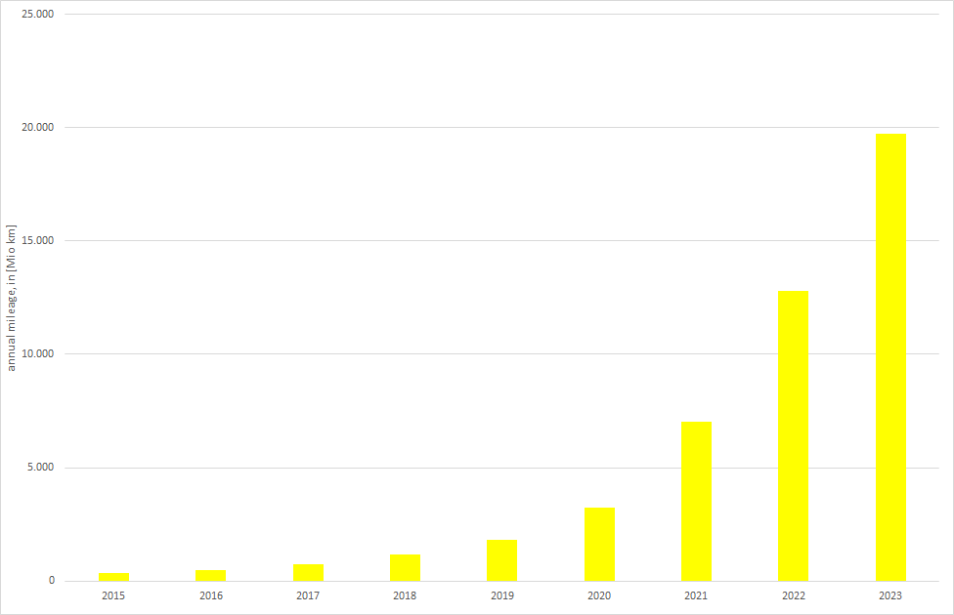 Annual mileage of electric road vehicles

Shifting of fuel purchases to other countries
Because fuel prices in Germany are higher – significantly, in some cases – than in almost all of Germany's neighbours (Denmark is the only exception), for some time the fuels used in Germany have included fuels purchased in other countries and brought into the country as “grey” imports.
At present, no precise data are available on this phenomenon, which is significant for Germany's border regions and which is referred to as “refuelling tourism” (“Tanktourismus”). Although several detailed studies have been carried out, no reliable overall picture of the situation is yet available (cf. Lenk et al., 2004 ). The sources that have documented shifting of consumers' fuel purchases to other countries (along with the resulting negative impacts on neighbouring countries' own emissions inventories) have included a study published by the Austrian Federal Ministry of Agriculture, Forestry, Environment and Water Management (BMLFUW, 2005 ).

Emission factors
All emission factors are listed in the “Handbook Emission Factors for Road Transport 4.1” (Notter et al., (2019) ), a reference work prepared via co-operation, between the environmental protection agencies of Germany, Switzerland and Austria also supported by Sweden, Norway, France as well as the JRC (European Research Center of the European Commission), in derivation of emission factors for road traffic. The emission factors in the manual originate predominantly from the measurement programmes of TÜV Rheinland (TÜV, Technical Control Association) and RWTÜV. Those programmes have included fundamental surveys for the reference years 1989/1990. In those surveys, a new method was used, for both passenger cars and heavy duty vehicles, whereby emission factors were derived according to driving habits and the traffic situation. Within the context of field monitoring data, the passenger-car emission factors were updated for cars produced up to 1994. Version 3.4 of the “Emission-factor Manual for Road Transports” (“Handbuch der Emissionsfaktoren des Straßenverkehrs”: HBEFA), which is used for the current emissions calculations, draws on findings of the EU working group COST 346 and the ARTEMIS research programme. The emission factors are derived from the development of the various vehicle layers and from the data provided by the HBEFA. The emissions reduction achieved via the introduction of sulphur-free fuels was estimated by the German Environment Agency.

Derivation of emission factors

Emission factors from TREMOD
In the CSE, emission factors for the “engines” (“Antrieb”) category are listed in [kg/TJ], while those for the “Evaporation” category are given in [kg/t]. For gasoline, diesel oil, LPG and CNG, these values can be derived from TREMOD for all structural elements. To this end, emissions (in tonnes [t]) and energy consumption (in terajoules [TJ]; converted from the results “energy consumption in t”, using the net calorific values) are derived from the TREMOD results and allocated to the relevant structural elements. The emission factor for each structural element then results as the quotient resulting from emissions, in tonnes per structural element, divided by the energy consumption, per structural element, in terajoule.
A similar procedure is used to obtain the emission factors for fugitive emissions, in [kg/consumption on municipal roads], in tonnes [t]). For purposes of this derivation, TREMOD results without correction to the Energy Balance are used, since such correction is already contained in the activity data for the CSE. Use of the corrected values (emissions and energy consumption) leads to the same results, however, since the correction factor cancels out in calculation of mean emission factors (emissions corrected / energy corrected = emissions uncorrected / energy uncorrected).

Emission factors for biodiesel, bioethanol, petroleum, Liquefied Petroleum Gas (LPG), and Compressed Natural Gas (CNG)
The emission factors for biodiesel and petroleum are set at the same values as those for conventional diesel fuel. The emission factors for bioethanol are set at the same values as those for conventional gasoline.
Exception: * The SO,,2,, emission factor for petroleum is set to 24 kg/TJ for those years in which diesel fuel has a higher value. In all other years, the lower value for diesel fuel is used.
Knörr et al. (2002): Knörr, W., Höpfner, U., & Lambrecht, U. (2002): Aktualisierung des “Daten- und Rechenmodells”: Energieverbrauch und Schadstoffemissionen des motorisierten Verkehrs in Deutschland 1980-2020 : Endbericht / Wolfram Knörr (Projektleiter): Heidelberg [u.a.] 2002. Knörr et al. (2020a): Knörr, W., Heidt, C., Gores, S., & Bergk, F.: ifeu Institute for Energy and Environmental Research (Institut für Energie- und Umweltforschung Heidelberg gGmbH, ifeu): Fortschreibung des Daten- und Rechenmodells: Energieverbrauch und Schadstoffemissionen des motorisierten Verkehrs in Deutschland 1960-2035, sowie TREMOD, im Auftrag des Umweltbundesamtes, Heidelberg & Berlin, 2020. . IVT, 2004: Institut für angewandte Verkehrs- und tourismusforschung e.V.: Fahrleistungserhebung 2002, Teil: Begleitung und Auswertung. Untersuchung im Auftrag der Bundesanstalt für Straßenwesen, Projektnummer FE 82.201/2001. Heilbronn/Mannheim. BASt, 2007: Federal Highway Research Institute (Bundesanstalt für Straßenwesen, BASt): Unterreihe Verkehrstechnik; V 164: “Straßenverkehrszählung 2005: Ergebnisse”, Thorsten Kathmann, Hartmut Ziegler, Bernd Thomas; 62 Seiten; Bergisch Gladbach, 2007. Lenk et. al (2004): Lenk, T., Vogelbusch, F., & Falken, C.: Auswirkungen des Tanktourismus auf das deutsche Steueraufkommen – eine finanzwissenschaftliche Bestandsaufnahme. Paper presented at the UNITI Bundesverband mittelständischer Mineralölunternehmen e. V. - Mitgliederversammlung 2004, München. BMLFUW, 2005: Federal Ministry for Agriculture, Forestry, Environment and Water Management (Bundesministerium für Land- und Forstwirtschaft, Umwelt und Wasserwirtschaft): Abschätzung der Auswirkungen des Tanktourismus auf den Treibstoffverbrauch und die Entwicklung der CO,,2,,-Emissionen in Österreich.; Wien, 2005. Notter et al., (2007): Notter, B., Keller, M., Althaus, H.-J., Cox, B., Knörr, W., Heidt, Chr., Biemann, K., Räder, D., Jamet M.: Handbuch für Emissionsfaktoren des Straßenverkehrs (HBEFA) Version 4.1. from MK Consulting GmbH, INFRAS AG & IVT / TU Graz; https://www.hbefa.net/d/documents/HBEFA41_Development_Report.pdf; Bern, 2019.

