Explanation of Key Trends - Carbon Monoxide

Main drivers
CO total emissions show a falling trend over the whole interval, with emission reductions of 80.6 % between 1990 and 2021 and a renewed interval of emission reductions in the last years.
The Main Driver for CO emissions is Fuel Combustion (NFR 1.A) with 90% of total 1990 emissions and an 86% reduction between 1990 and 2021. In the Fuel Combustion category, Road Transport (NFR 1.A.3.b) is responsible for 57% of the 1990 emissions, with Passenger Cars (NFR 1.A.3.b.i) emitting nearly all of it. Reductions of about 89% in those categories between 1990 and 2021 are mainly due to constantly improving fuels and increasingly stricter regulations resulting in technical improvements.
Other Sectors (NFR 1.A.4, including commercial/institutional and residential sources) are responsible for about 27% of 1990 Fuel Combustion emissions with a 82% reduction between 1990 and 2021.
Table: Carbon monoxide emissions 1990-2021, in kilotonnes [kt]
Total Emissions (kt) |  |  |  |  |  |  |  |  |  |  |  |  |  |  |  | Trend: latest compared to
1990 | 1995 | 2000 | 2005 | 2010 | 2011 | 2012 | 2013 | 2014 | 2015 | 2016 | 2017 | 2018 | 2019 | 2020 | 2021 | 1990 | last years
13,354 | 7,234 | 5,146 | 3,863 | 3,536 | 3,457 | 3,206 | 3,168 | 3,000 | 3,102 | 2,973 | 2,981 | 2,863 | 2,756 | 2,454 | 2,587 | -80.6%  down | down
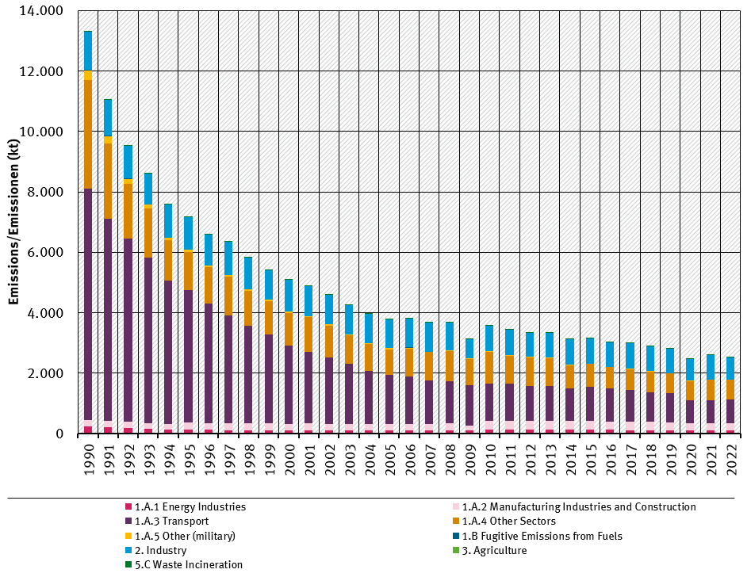 trend of cO emissions, by sector
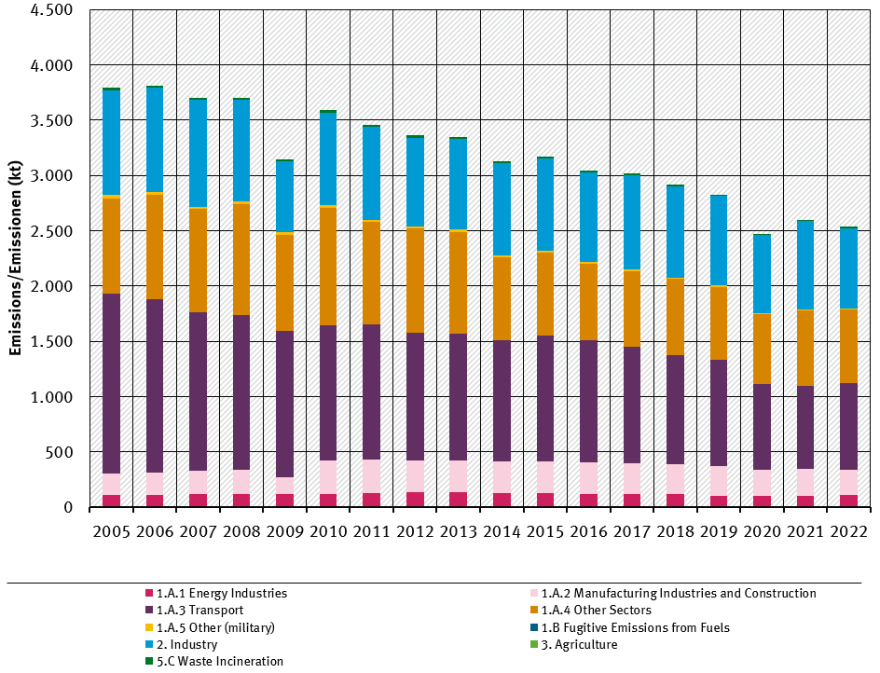 trend of cO emissions, by sector, from 2005

