1.A.2.g viii - Stationary Combustion in Manufacturing Industries and Construction: Other

Short description
Source category 1.A.2.g viii - Stationary Combustion in Manufacturing Industries and Construction: Other comprises stationary combustion systems for heat and power production of industrial power plants and industrial boiler systems.
NFR Code | Method | AD | EF
1.A.2.g viii | T2 | NS | CS
Method(s) applied
D | Default
T1 | Tier 1 / Simple Methodology *
T2 | Tier 2*
T3 | Tier 3 / Detailed Methodology *
C | CORINAIR
CS | Country Specific
M | Model
* as described in the EMEP/EEA Emission Inventory Guidebook - 2019, in category chapters.
(source for) Activity Data
NS | National Statistics
RS | Regional Statistics
IS | International Statistics
PS | Plant Specific
As | Associations, business organisations
Q | specific Questionnaires (or surveys)
M | Model / Modelled
C | Confidential
(source for) Emission Factors
D | Default (EMEP Guidebook)
CS | Country Specific
PS | Plant Specific
M | Model / Modelled
C | Confidential

NOx | NMVOC | SO2 | NH3 | PM2.5 | PM10 | TSP | BC | CO | Pb | Cd | Hg | As | Cr | Cu | Ni | Se | Zn | PCDD/F | B(a)P | B(b)F | B(k)F | I(x)P | PAH1-4 | HCB | PCBs
L/T | -/- | L/T | -/- | L/- | -/- | L/T | -/- | -/- | -/- | L/- | L/T | L/T | L/T | -/T | L/T | -/- | L/T | L/T | -/T | IE | IE | IE | -/T | -/- | -/-
Method(s) applied
D | Default
T1 | Tier 1 / Simple Methodology *
T2 | Tier 2*
T3 | Tier 3 / Detailed Methodology *
C | CORINAIR
CS | Country Specific
M | Model
* as described in the EMEP/EEA Emission Inventory Guidebook - 2019, in category chapters.
(source for) Activity Data
NS | National Statistics
RS | Regional Statistics
IS | International Statistics
PS | Plant Specific
As | Associations, business organisations
Q | specific Questionnaires (or surveys)
M | Model / Modelled
C | Confidential
(source for) Emission Factors
D | Default (EMEP Guidebook)
CS | Country Specific
PS | Plant Specific
M | Model / Modelled
C | Confidential

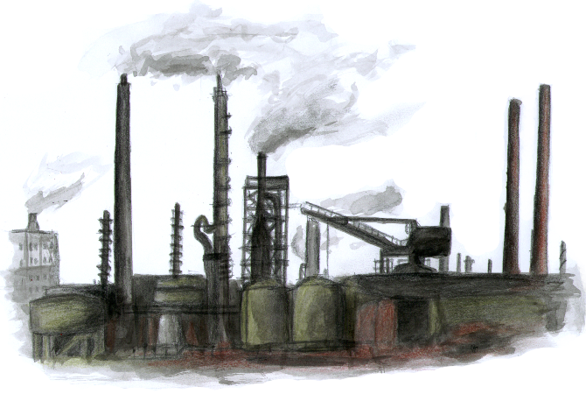 Illustration of Sachtleben Chemie

Method
Generally, the calculation method is based on a Tier 2 approach. This means the use of country-specific data at a more detailed level. Emission factors and activity data are available for different fuel types, different technologies, plant size, etc. The use of plant-specific data for a bottom-up approach is not possible. Emissions from industrial power plants cannot be allocated clearly to source category 1.A.2, since reality does not follow the definition of the Guidebook. In real life an industrial power plant generates electricity and heat for the industry but also electricity for the public network. Therefore the borderline between these two categories is not fixed. The market is not static. Frequent changes in the cooperate structure of industrial enterprises including the separation of the energy supply via spin-off from the parent company lead to frequent changes between sector 1.A.1.a, 1.A.1.c and 1.A.2. Therefore it was necessary to develop a flexible calculation system, based on robust emission factors, which can be used for all sectors. Source category 1.A.2.g.viii does only include emissions from industrial power plants and boiler systems.

Activity data

Conventional fuels
The key source of all conventional fuel data is the national energy balance AGEB, 2022: National energy balance and Satellite balance for renewable energy: https://ag-energiebilanzen.de/en/data-and-facts/energy-balance-2000-to-2030/ . Moreover the use of additional statistical data is necessary in order to disaggregate data. Data source for fuel inputs for electricity generation in industrial power stations are shown in Energy Balance line 12. The difference resulting after deduction of the fuel inputs for refinery power stations, pit power stations, power stations in the hard-coal-mining sector and, for the period until 1999, for the power stations of German Railways (Deutsche Bahn) consists of the activity data for other industrial power stations. These data cannot be further differentiated. Additional data from the Federal Statistical Office are needed for allocation of fuel inputs to heat production in industrial power stations and boiler systems. For both electricity production and heat production, gas turbines, gas and steam systems and gas engines are differentiated. These detailed information is provided by the national statistic 067 (industrial power stations). The definition of industrial and public power plants follows the National statistics.

Biomass
Along with the main Energy Balance, a Satellite Balance of renewable Energies (Satellitenbilanz Erneuerbarer Energieträger) is also published. This balance describes the growth and use of renewable energies in detail. This is the database for all biomass fuels excluding waste.

Waste
With regard to determination of activity data from waste incineration and co-combustion of waste in combustion system in source category 1.A.2 Energy Balance and energy statistics show smaller waste quantities than the waste statistics of the Federal Statistical Office (Statistisches Bundesamt, Fachserie 19, Reihe 1). For that reason activity data were taken from waste statistics.

Emission factors
The emission factors for power stations and other boiler combustion for production of steam and hot water, in source category 1.A.2.g.viii, have been taken from the research project “Determination and evaluation of emission factors for combustion systems in Germany for the years 1995, 2000 and 2010” (RENTZ et al., 2002).
In 2018 and 2019 SO2, NOx, TSP, PM, CO, NH3 and Hg emission factors were revised for all large combustion plants by using data from the large combustion plant reporting (UBA 2019). A detailed description of the procedure is presented in Chapter: 1.A.1.a - Public Electricity And Heat Production. This chapter contains also information about emission factors of engines and waste incineration plants. In terms of black carbon default emission factors for the EMEP EEA Guidebook 2019 are used.
Table 1: Implied emission factors for industrial electricity and heat generation for 2023
 | SOx | NOx | TSP | CO | Pb | Hg | Cd
 | [kg/TJ] |  |  |  | [g/TJ]
Hard Coal | 142.9 | 101.2 | 3.3 | 25.9 | 4.98 | 2.34 | 0.36
Lignite | 190.0 | 90.0 | 4.9 | 45.7 | 1.53 | 2.46 | 0.20
Natural gas | 0.1 | 41.3 | 0.2 | 10.5 | NA | 0.01 | NA
Liquid fuels | 33.3 | 53.4 | 1.4 | 5.6 | 0.75 | 0.24 | 0.06
Biomass | 9.5 | 131.9 | 16.7 | 50.7 | 0.39 | 0.17 | 0.49
Hazardous waste | 0.5 | 69.2 | 0.2 | 7.8 | 4.90 | 0.34 | 1.10
The table gives an overview of the implied emission factors. In reality the German inventory compiling process is very complex and includes the use of a considerable number of emission factors, which cannot be published completely in the IIR.
Actually there are different emission factors available for diverse fuel types, various techniques and due to permissions. However, the implied emission factor may give an impression about the order of magnitude. PM10 and PM2.5 emission factors are calculated as a fraction of TSP. The share of PM10 is 90 % and the share of PM2.5 is 80 % for solid fuels. This is a simple but also conservative approach, knowing that, in reality, PM emissions depend on fuel, combustion and abatement technologies. In terms of natural gas and biogas PM10 and PM2.5 fractions are considered as 100 % of TSP. Regarding wood a share of 100% PM10 and 90% PM2.5 is used. For liquid fuels the default share of 100% PM10 and PM2.5 is used. In the cases of co-incineration, where liquid fuels are only used for ignition in coal fired plants, the share of coal fired plants is used. PM emission reporting starts in 1995, since no sufficient information about the dust composition of the early 1990s is available.

Trend Discussion for Key Sources
The following diagrams give an overview and assistance for explaining dominant emission trends of selected pollutant.

Sulfur Oxides & Nitrogen Oxides - SOx & NOx
As already discussed in source category 1.A.1.c, SOx emission trend is very much influenced by emissions from lignite fired plants. The strong decline of lignite use in the East German industry and the installation of flue gas desulfurisation plants in the remaining heat and power stations are the main reasons for decreasing SOx emissions.
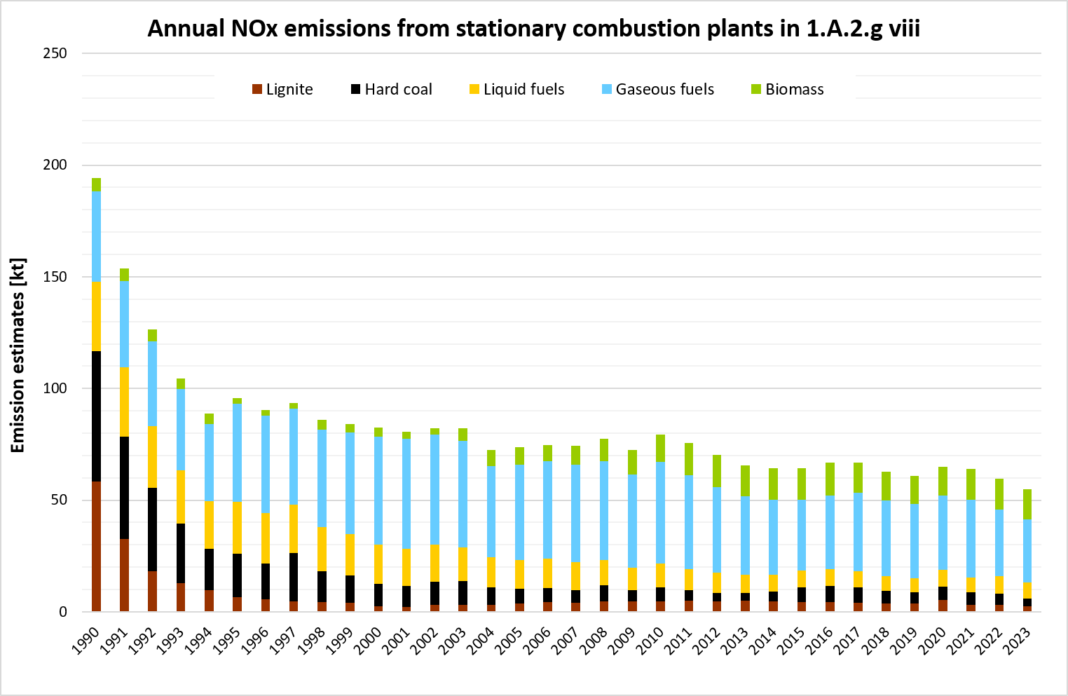 Annual emissions of NOx from stationary plants in 1.A.2.g.vii
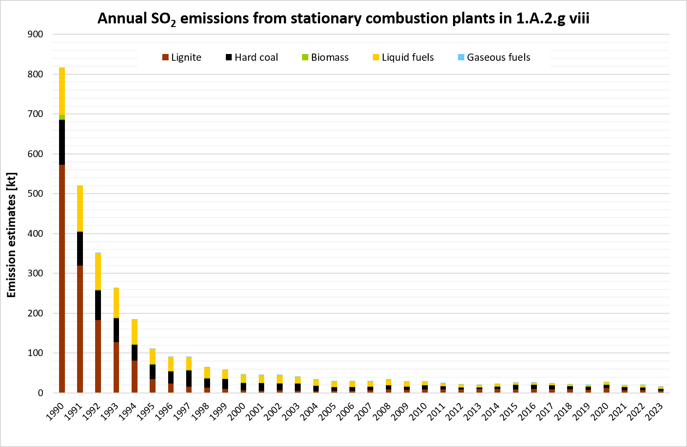 Annual emissions of SOx from stationary plants in 1.A.2.g.vii

Particulate Matter (TSP, PM10) and Priority Heavy Metals (Hg & Cd)
The main driver of TSP and heavy metal emission trends is the declining lignite combustion due to the closure of industrial plants in the East German industry especially from 1990 to 1994. Furthermore, the noticeable improvement of dust extraction installations and the optimisation of the combustion process resulted in considerably decreasing TSP and heavy metal emissions.
In recent years the use of biomass gains influence.
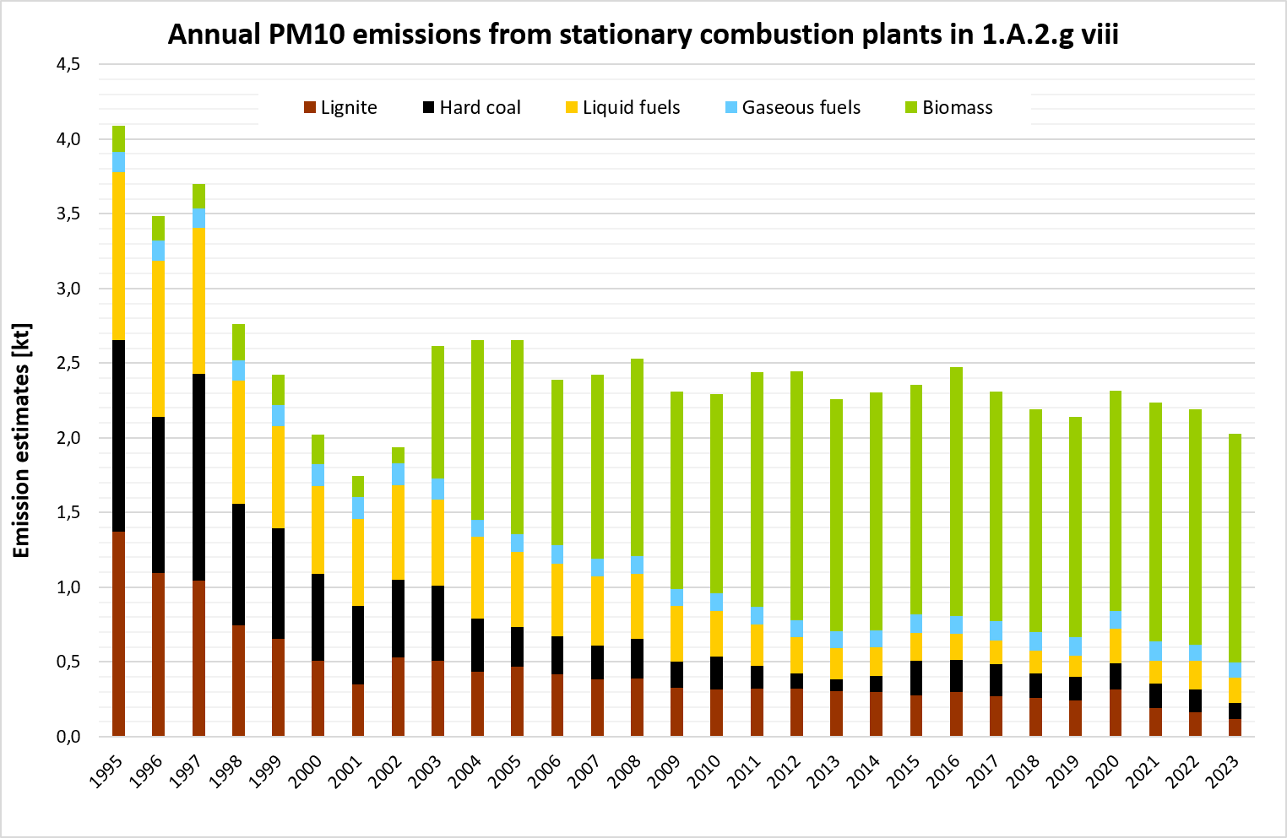Annual emissions of PM10 from stationary plants in 1.A.2.g.vii
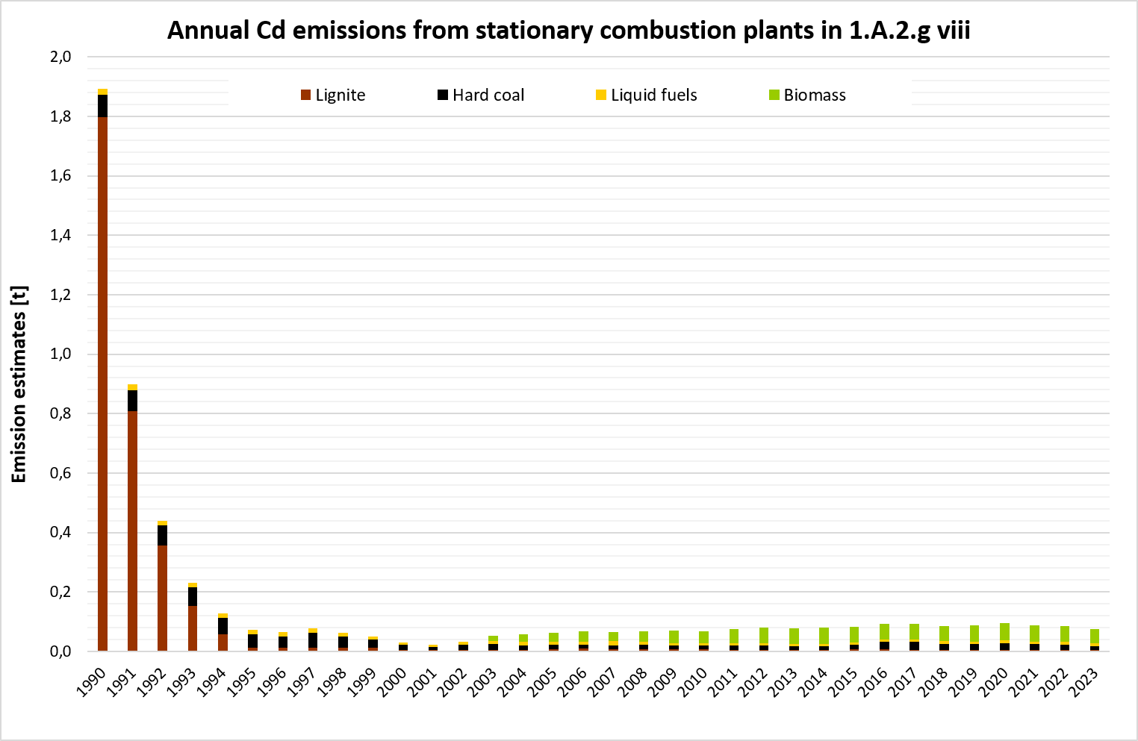Annual emissions of Cd from stationary plants in 1.A.2.g.vii
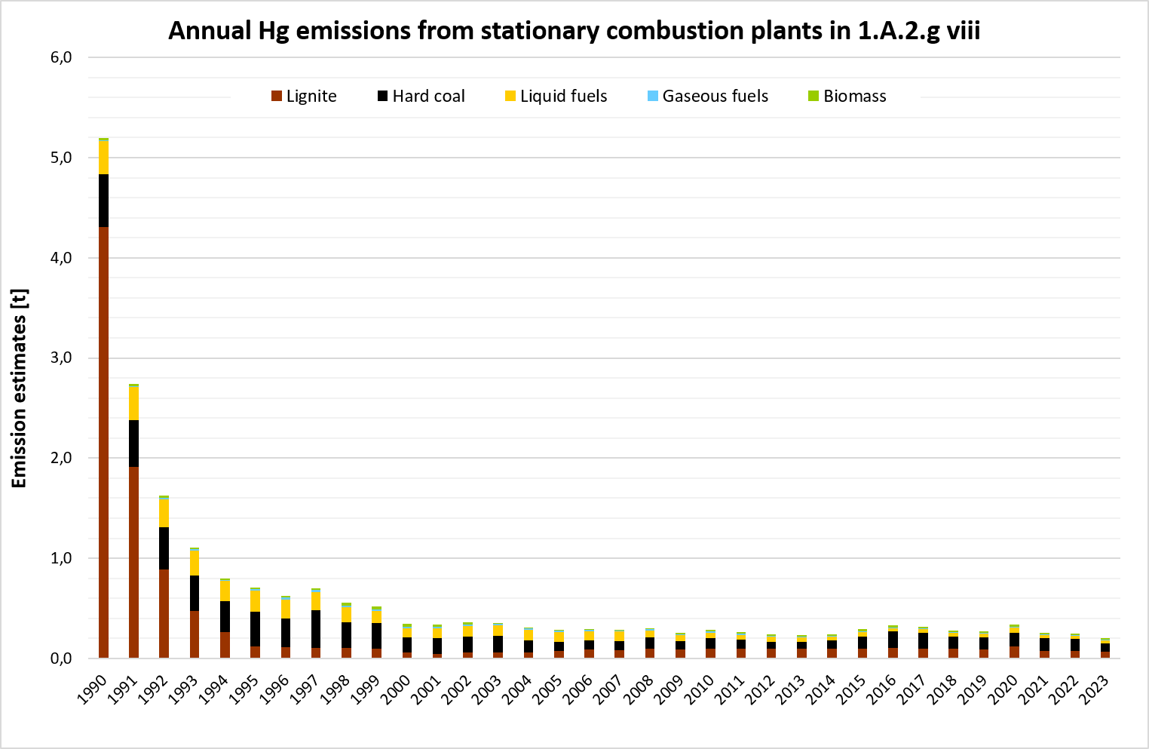Annual emissions of Hg from stationary plants in 1.A.2.g.vii
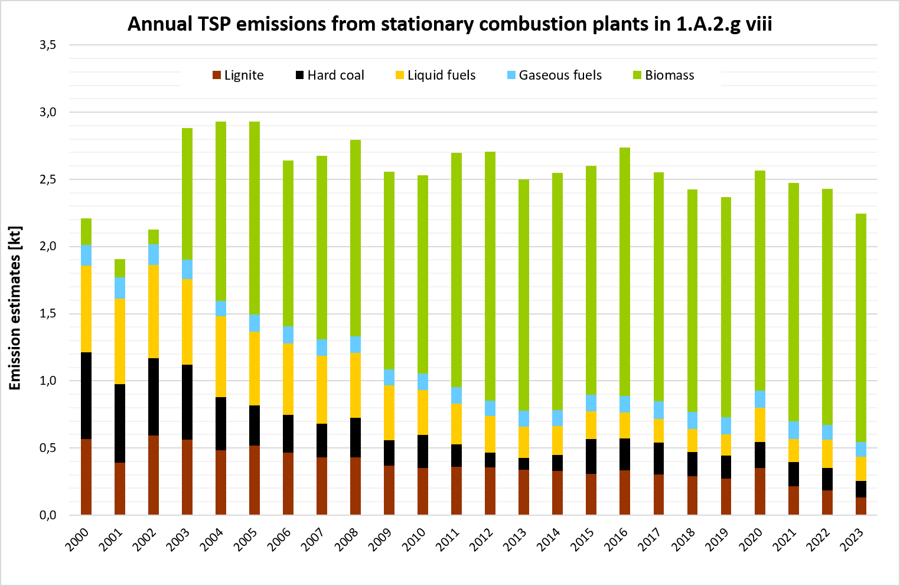Annual emissions of TSP from stationary plants in 1.A.2.g.vii, details from 2000 on
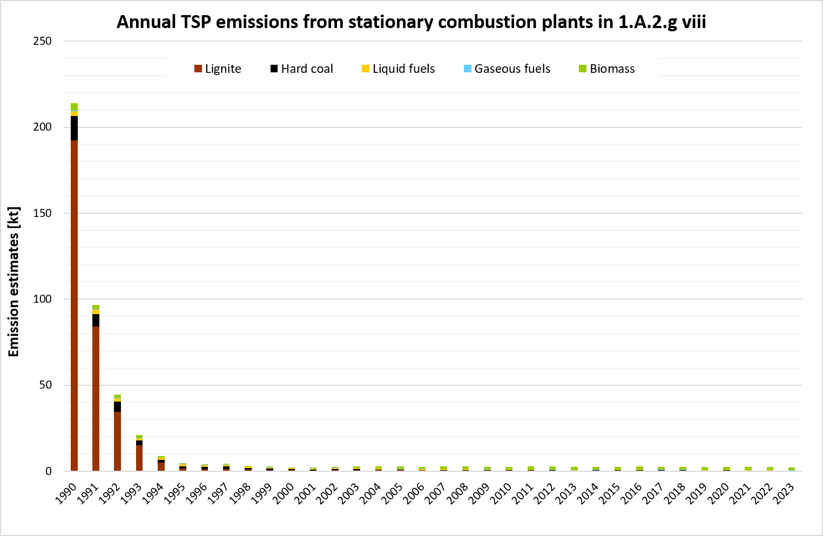Annual emissions of TSP from stationary plants in 1.A.2.g.vii

Persistent Organic Pollutants
PCDD and PCDF emissions show a decreasing trend over the whole timeseries due to decreasing fuel consumption in the industry sector.
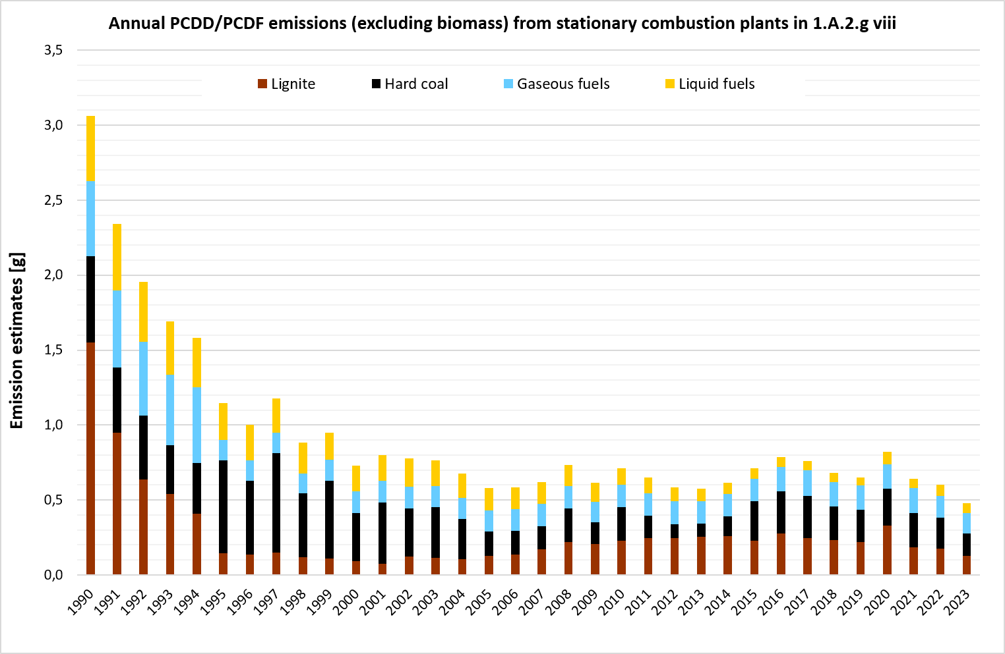Annual emissions of PCDDF from stationary plants in 1.A.2.g.vii

Recalculations
At the time of compiling the inventory, national energy balance is only available provisionally. Therefore, the finalization of the Energy Balance for 2022 led to recalculations. In addition, to ensure that consumption of fuels in the official data sources is consistently included in the inventory, reallocation of fuel data between 1.A.1.b, 1.A.1.c and 1.A.2.g viii took place for the years 2003-2022.
For pollutant-specific information on recalculated emission estimates for Base Year and 2022, please see the pollutant specific recalculation tables following chapter 9.1 - Recalculations.

Planned improvements
At the moment, no category-specific improvements are planned.
Destatis (2024a): Federal Statistical Office (Statistisches Bundesamt - Destatis): Fachserie 19, Reihe 1: Abfallentsorgung (now data on waste management are available from the GENESIS-Online database) - URL: http://www.destatis.de/DE/Themen/Gesellschaft-Umwelt/Umwelt/Abfallwirtschaft/_inhalt.html#sprg238672, Wiesbaden, 2024. Rentz et al. (2002): Rentz, O., Karl, U., Peter, H.: Ermittlung und Evaluierung von Emissionsfaktoren für Feuerungsanlagen in Deutschland für die Jahre 1995, 2000 und 2010: Forschungsbericht 299 43 142; on behalf of the Umweltbundesamt; final report; Deutsch-Französisches Inst. f. Umweltforschung, Univ. (TH); https://publikationen.bibliothek.kit.edu/21412002; Karlsruhe / Dessau-Roßlau, 2002. Umweltbundesamt (2019): Juhrich, K., Beckers, R.: “Updating the Emission Factors for Large Combustion Plants”: https://www.umweltbundesamt.de/publikationen/updating-emission-factors-large-combustion-plants; Dessau-Roßlau, 2002.

