1.B.1 - Solid Fuels
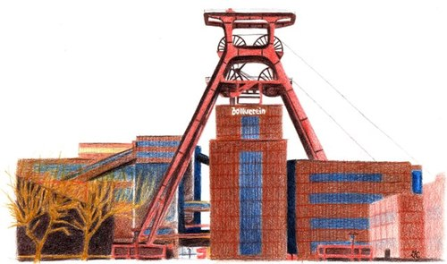

Short description
Category Code | Method |  |  |  |  | AD |  |  |  |  | EF
1.B.1.a | T2, M |  |  |  |  | AS |  |  |  |  | CS
1.B.1.b | T2, T3 |  |  |  |  | AS |  |  |  |  | CS
Key Category | NOx | NMVOC | SO2 | NH3 | PM2.5 | PM10 | TSP | BC | CO | PB | Cd | Hg | Diox | PAH | HCB
1.B.1.a | - | -/- | - | - | -/- | -/- | -/- | - | - | - | - | - | - | - | -
1.B.1.b | -/- | -/- | -/- | -/- | -/- | -/- | L/T | -/- | -/- | - | - | -/- | -/- | -/T | -
.
Method(s) applied
D | Default
T1 | Tier 1 / Simple Methodology *
T2 | Tier 2*
T3 | Tier 3 / Detailed Methodology *
C | CORINAIR
CS | Country Specific
M | Model
* as described in the EMEP/EEA Emission Inventory Guidebook - 2019, in category chapters.
(source for) Activity Data
NS | National Statistics
RS | Regional Statistics
IS | International Statistics
PS | Plant Specific
As | Associations, business organisations
Q | specific Questionnaires (or surveys)
M | Model / Modelled
C | Confidential
(source for) Emission Factors
D | Default (EMEP Guidebook)
CS | Country Specific
PS | Plant Specific
M | Model / Modelled
C | Confidential
.
The source category Solid fuels (1.B.1) consists of two sub-source subcategories – the source subcategory Coal mining (1.B.1.a) and the source subcategory Coal transformation (1.B.1.b). This chapter discusses fugitive emissions from coal mining, coal handling, including door leakages from coke ovens and quenching (emissions from the furnace are covered by category 1.A.1.c), and emissions from the beneficiation of solid fuels. In the mining sector, a distinction is made between open-pit mines, in which raw materials are extracted from pits open to the surface, and closed-pit mines, in which seams are mined underground. In Germany, hard coal used to be mined in closed-pits only (until 2018), while lignite is mined in four coal fields since 2003 with the open-pit method only.
Unitil 2018 Germany produced significant amounts of hard coal in underground mines. Since 2019, hard coal has been imported exclusively. NMVOC emissions are considered insignificant as the coal outgased along the import route. Particle emissions from loading and unloading as well as storage are reported under 2.L(a) - Handling of Bulk Products“

Methodology

Lignite production
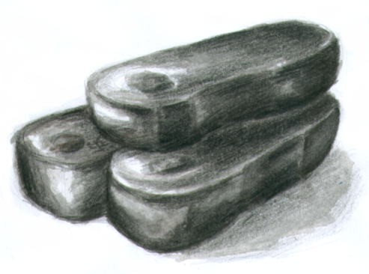
Activity data for lignite production have been taken from the Statistik der Kohlenwirtschaft’s website (in German only) . Extracted coal is moved directly to processing and to power stations.
The emission factors used for calculating emissions from lignite production (TSP, PM10 and PM2.5) already include possible emissions from transport and storage. The PM10 factor is taken from a 2021 research project . TSP and PM2.5 have been reduced the same way on the basis of the previous values.
Table 1: Annual amounts of extracted raw lignite, in [Mt]
1990 | 1995 | 2000 | 2005 | 2010 | 2015 | 2020 | 2022
357 | 193 | 168 | 178 | 169 | 178 | 107 | 131
Table 2: Emission factors applied for lignite extraction, in [kg/t]
Pollutant | Value
TSP | 0.03
PM10 | 0.015
PM2.5 | 0.002

Lignite coke production
Table 3: Annual amounts of lignite coke produced, in [Mt]
1990 | 1995 | 2000 | 2005 | 2010 | 2015 | 2020 | 2022
3.3 | 0.2 | 0.2 | 0.2 | 0.2 | 0.2 | 0.1 | 0.1
Emissions from lignite production other than listed below are reported by plant operator. Particle emission factors were verified in a research project (Emissionen und Maßnahmenanalyse Feinstaub 2000-2020) .
Table 4: Emission factors applied for lignite-coke production
Pollutant | Unit | Value
TSP | kg/t | 0.1
PM10 | kg/t | 0.048
PM2.5 | kg/t | 0.013
PAH | mg/t | 55
PCDD/F | µg/t | 0.03

Hard coal coke production
The activity rates for hard coal coke production have been taken from the Statistik der Kohlenwirtschafts’s website (in German only) .
Table 5: Annual amounts of hard coal coke produced, in [Mt]
1990 | 1995 | 2000 | 2005 | 2010 | 2015 | 2020 | 2022
18.5 | 11.1 | 9.1 | 8.4 | 8.2 | 8.8 | 7.9 | 8.3
The emission factors for hard coal coke production have been obtained from the research project “Emission factors for the iron and steel industry, for purposes of emissions reporting” (“Emissionsfaktoren zur Eisen- und Stahlindustrie für die Emissionsberichterstattung”) .
Table 6: Emission factors for hard coal coke production
Pollutant | Unit | Value
CO | kg/t | 0.015
NH3 | kg/t | 0.000243
NMVOC | kg/t | 0.096
SO2 | kg/t | 0.004
TSP | kg/t | 0.011
PM10 | kg/t | 0.004
PM2.5 | kg/t | 0.004
PAH | mg/t | 55
PCDD/F | µg/t | 0.0015
There are many potential sources of PAH emissions from coking plants. The dominant emission sources are leakages from coke oven doors and from charging operations. As there is limited data available on PAH emissions, the uncertainties of the estimated emission factors are very high. It should also be taken into account that emissions from coke production greatly vary between different coke production plants. The emission factors for benzo[a]pyrene and mixed PAH have been revised by research projects in 2010 . Split factors for Black Carbon (BC) are based on the EMEP Guidebook 2016 .

Decommissioned hard-coal mines
NMVOC Emissions from decommissioned hard-coal mines play a role in this sub- source category. When a hard-coal mine is decommissioned, mine gas can escape from neighbouring rock, and from coal remaining in the mine, into the mine's network of shafts and passageways. Since the mine is no longer artificially ventilated, the mine gas collects and can then reach the surface via gas pathways in the overlying rock or via the mine's own shafts and passageways. Such mine gas was long seen primarily as a negative environmental factor. Recently, increasing attention has been given to the gas' positive characteristics as a fuel (due to its high methane content, it is used for energy recovery). In the past, use of mine gas was rarely cost-effective. This situation changed fundamentally in 2000 with the Renewable Energy Sources Act (EEG). Although mine gas is a fossil fuel in finite supply, its use supports climate protection, and thus the gas was included in the EEG. The Act requires network operators to accept, and provide specified compensation for, electricity generated with mine gas and fed into the grid.
The NMVOC emissions from decommissioned hard-coal mines have been calculated in the research project “Potential for release and utilisation of mine gas” (“Potential zur Freisetzung und Verwertung von Grubengas”) . The relevant calculations were carried out for all mining-relevant deposits in Germany.
Table 7: NMVOC emission factor for decommissioned hard-coal mines, in [kg/m13]
EF
0.001599

Recalculations
For more details please refer to the super-ordinate chapter 1.B - Fugitive Emissions from fossil fuels

Planned improvements
No further improvements are planned.

References
Federal Environment Agency research project No. 204 42 202/2 “Emissionen und Maßnahmenanalyse Feinstaub 2000-2020”, published in 2007 External Link Co-ordinated European Programme on Particulate Matter Emission Inventories, Projections and Guidance (CEPMEIP) External Link Hensmann et al. 2011 Federal Environment Agency and DFIU research project “Anpassung der deutschen Methodik zur rechnerischen Emissionsermittlung an internationale Richtlinien, Teilbericht Prioritäre Quellen”, 2010 (not available online) Federal Environment Agency and BFI research project No. 3707 42 301 “Emissionsfaktoren zur Eisen- und Stahlindustrie für die Emissionsberichterstattung“, 2011 External Link EMEP/EEA Air Pollutant Emission Inventory Guidebook 2016; published in 2016 External Link (last pageview: Dec 2016) Neulicht, R. (1995): Emission Factor Documentation for AP-42 Section 10.7 “Charcoal”. External Link Meiners, H. (2014): Potential zur Freisetzung und Verwertung von Grubengas Statistik der Kohlenwirtschaft (2019) External Link (last pageview: March 2021) Dokumentation zur Berechnung des PM10-Austrags aus dem Tagebau Hambach im Jahr 2013 und Ableitung eines Emissionsfaktors (2021) External Link (last pageview: March 2023)

