Welcome to the German Informative Inventory Report 2023 (IIR 2023).
This report covers the preparation, maintenance, and improvement of the German air pollutant emission inventory.
Table of Contents
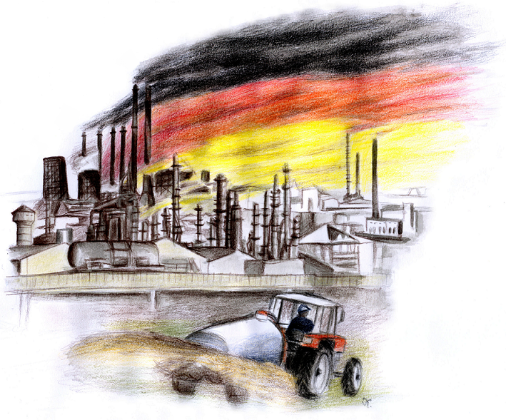
IMPRINT
Publisher:
UMWELTBUNDESAMT <br /> WOERLITZER PLATZ 1 | 06844 DESSAU-ROßLAU
PHONE: +49 (0)340-2103-0 | FAX: +49 (0)340-2103-2285 | E-MAIL: buergerservice[at]uba.de | INTERNET: www.umweltbundesamt.de
Report to be completed in: April 2023
Edited by: SECTION V 1.6 - EMISSION SITUATION | editor-in-chief: Michael Kotzulla
Dessau-Roßlau

